## NAME:MAINA BENADATAH WANJIRU.

## ADM/NO:DIT/242/23.

## INTERNET BASED PROGRAMMING ASSIGNMENT TWO:

* STEP 1:
* Creating a GitHub repository.

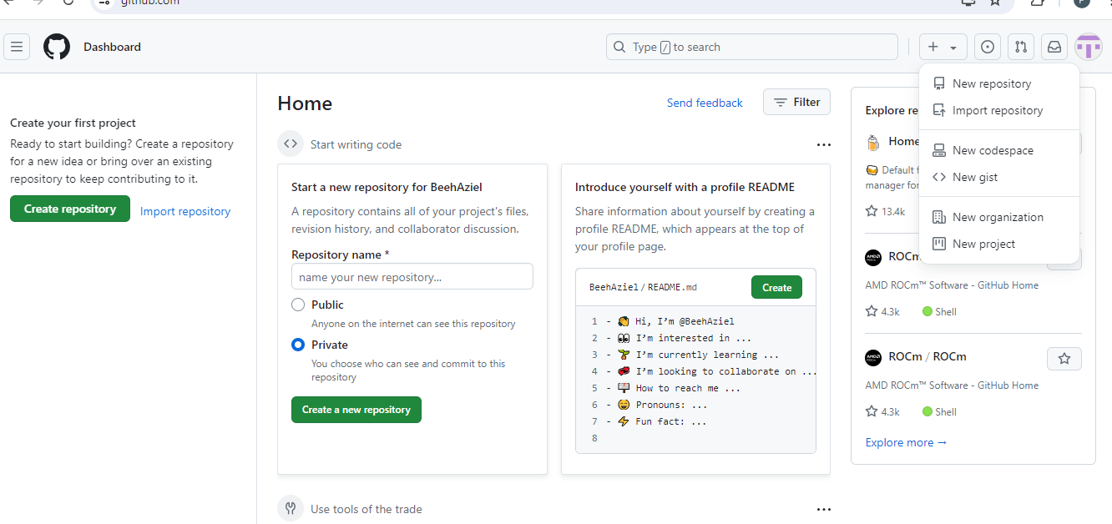

* Click the “+” icon on the upper left as shown in the screenshot.
* Select new repository.
* STEP 2
* Initialize the repository with a README.md file.

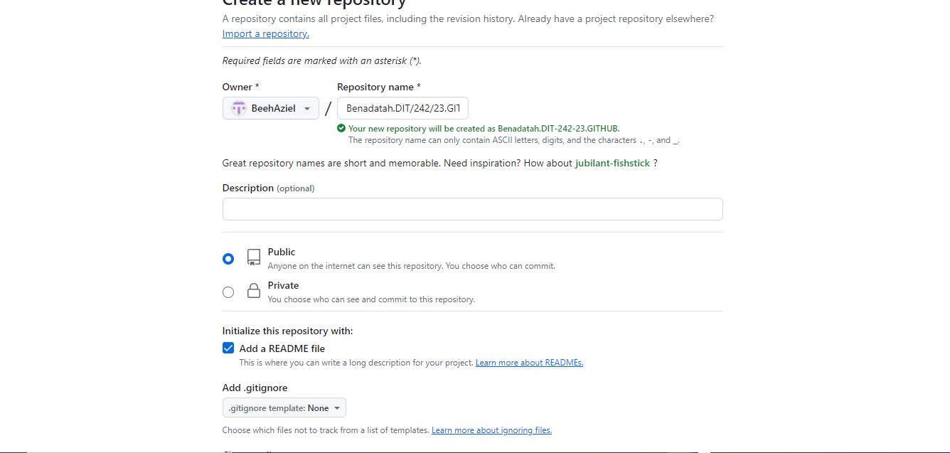

* Add the repository name firstname.registrationnamber.website. Like in the screenshoot above Benadatah.DIT/242/23.
* Initialize with a readme.md file.
* Set the repository to public.

STEP 3:

* Repository created.

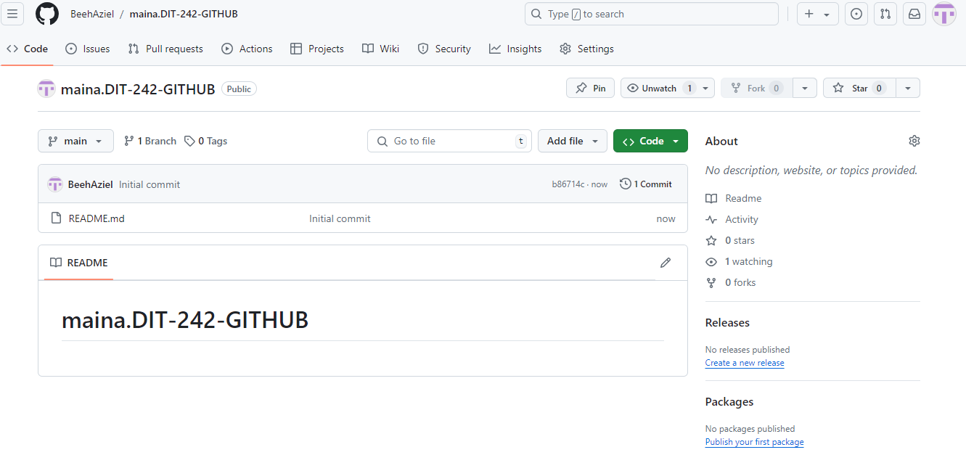

* Once the repository is created it should appear like the screenshot above.

Question two:

* Cloning the repository as shown in the screenshoot.

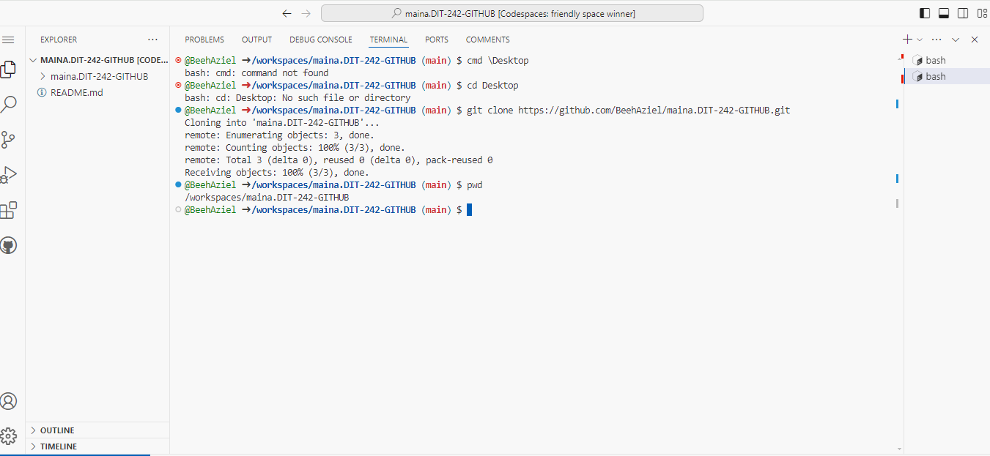

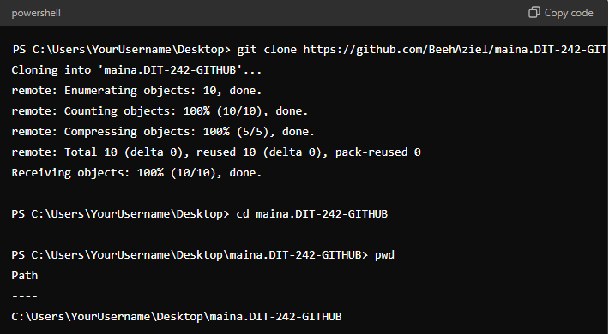

* Step 3.

Successful cloning of the github repository.

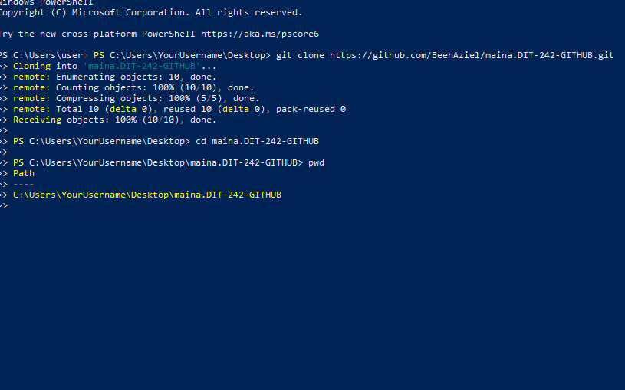

* Step 4.
* CREATING THE PROJECT STRUCTURE.
* Index html.
* Ttt 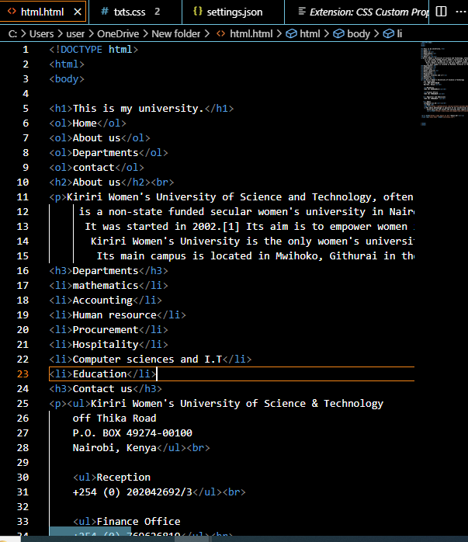

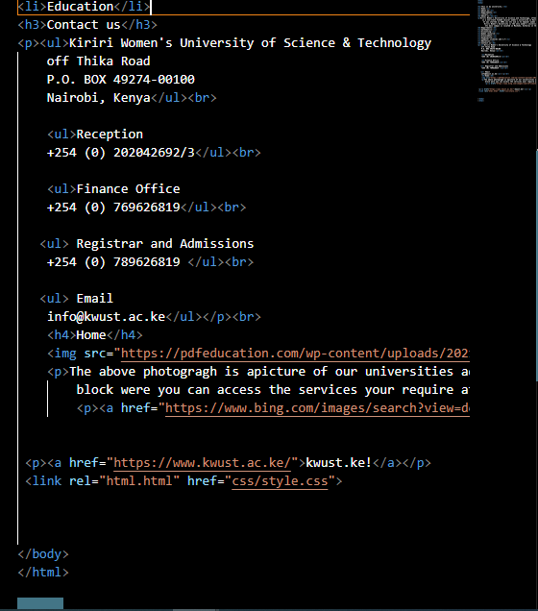

* By using visual studio code and my code space space I manage d to create the above html structure and after running my codes .
* The below diagram is screenshoot of my html structure.
* 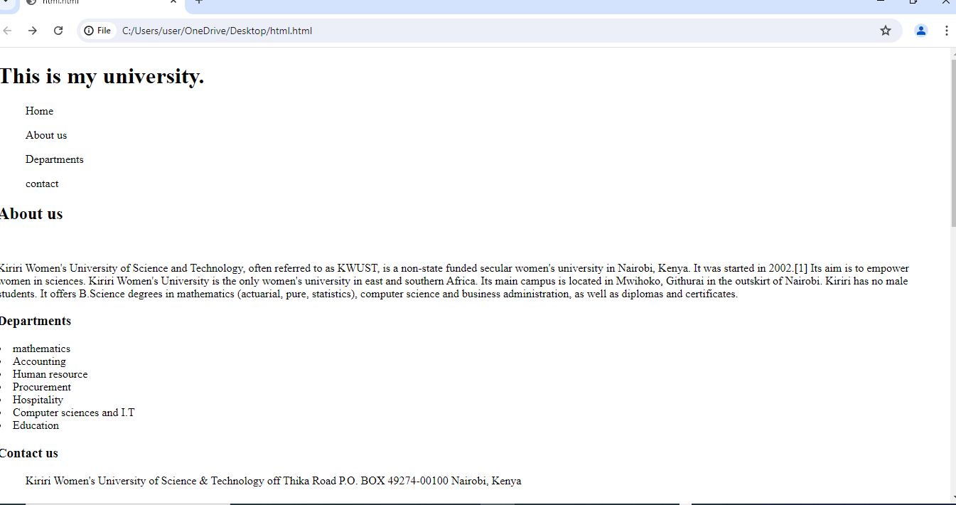



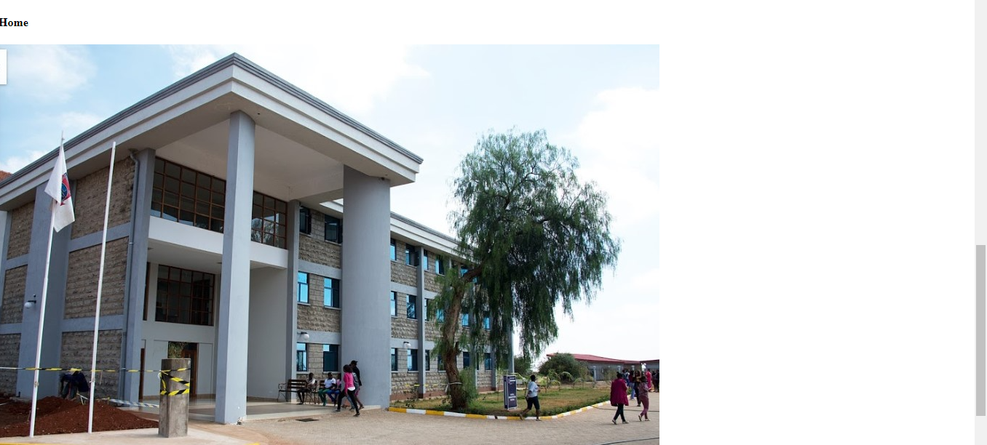

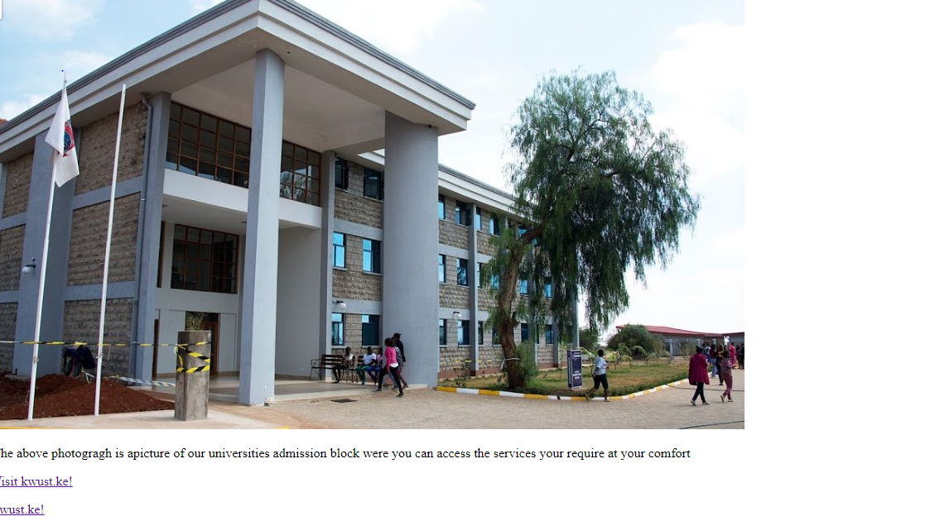

* After clicking my link the following is supposed to show a block of the admin block.
* The picture below shows the results.

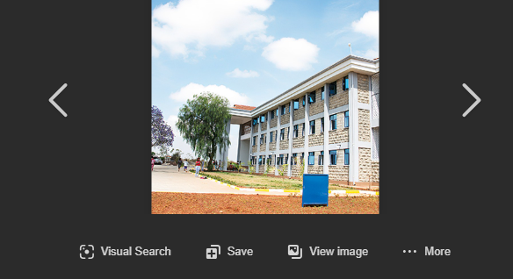

* Step five.
* Using css and linking it to my html;indexhtml.

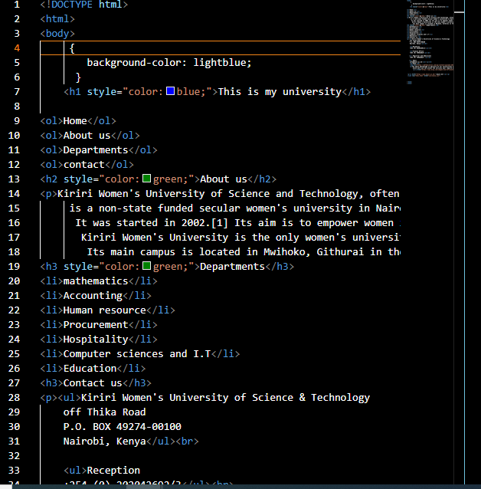

This what I managed to print out after afew css adding.the screenshoot below is a representation of it.

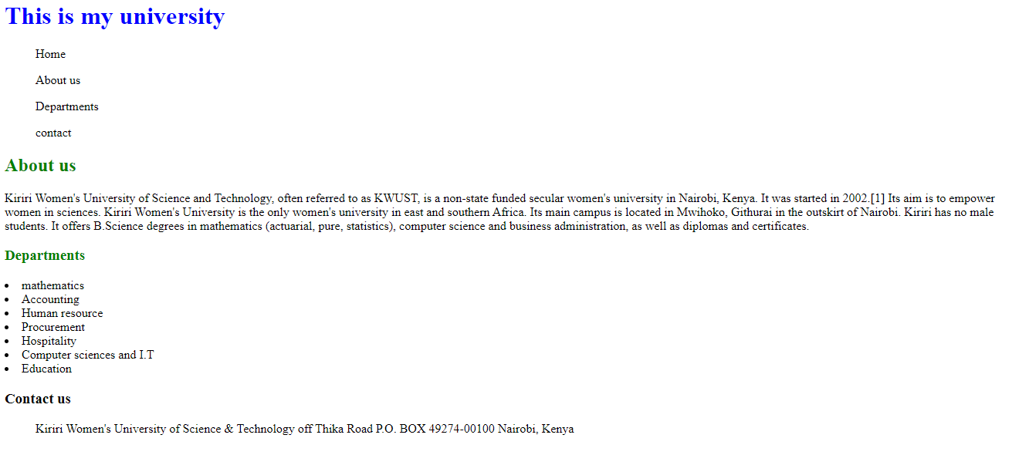

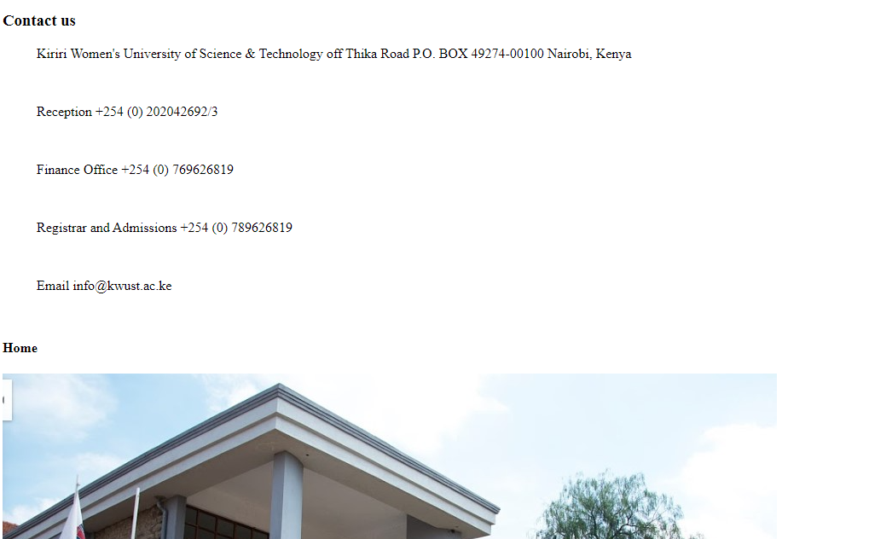

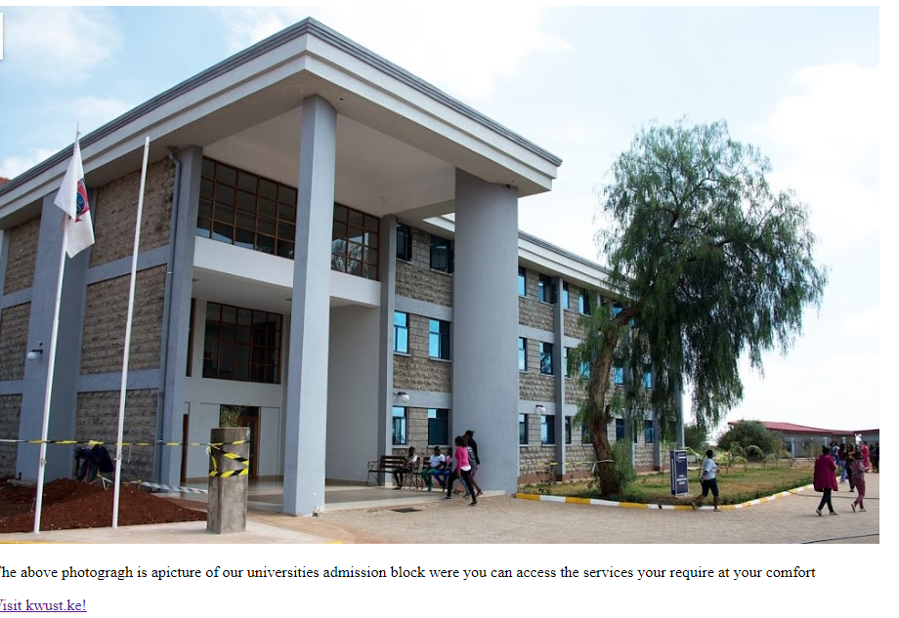

This is after using css to add some feature like color headings

Fonts and others

Step six

* Pushing the codes to Github.
* This is as shown in the screenshoot below.

to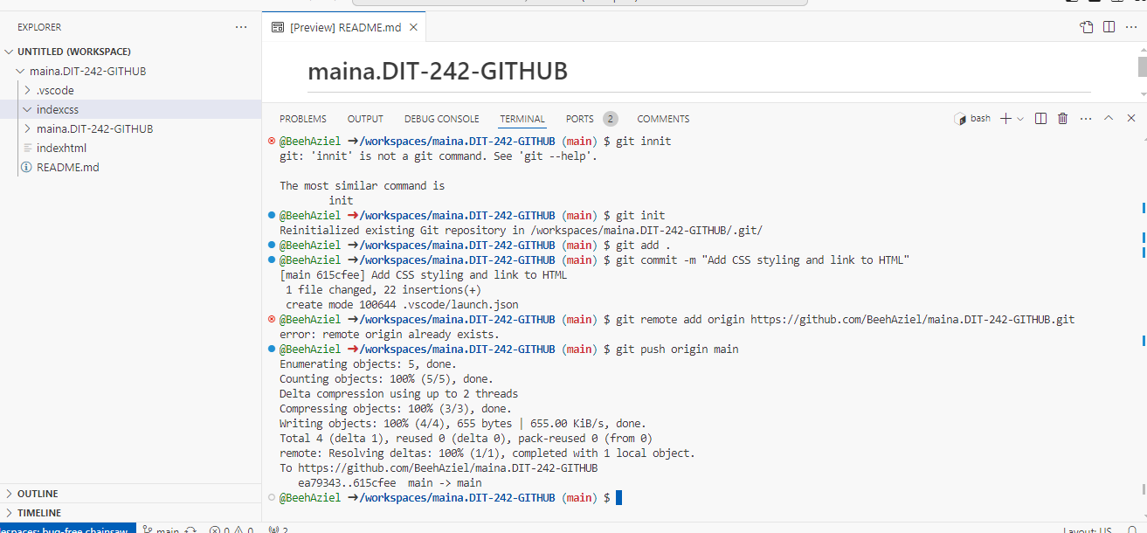

* This was done using terminals on my codespace through github.

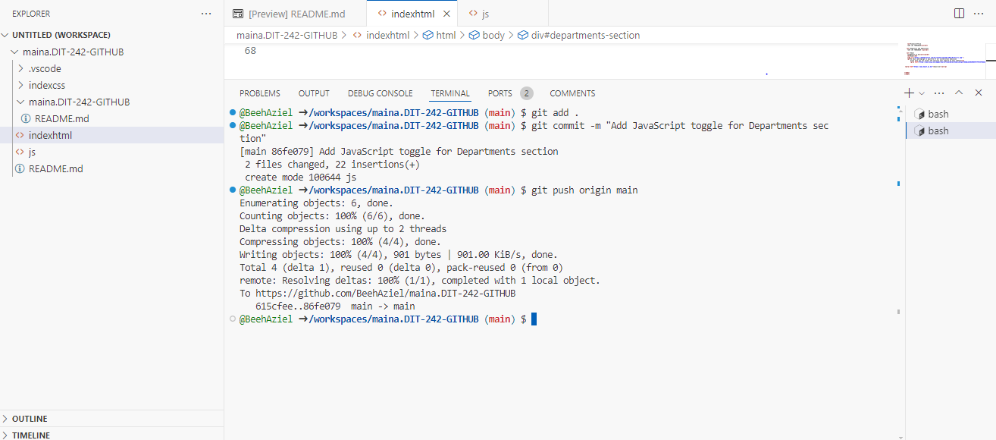

* <https://github.com/BeehAziel/Benadatah-Wanjiru-DIT-242-23-GITHUB.git>.